Ice Throw Management Procedure
Kestrel Ridge Wind Farm
Hannah Weber · 08 October 2025 · KR-HSE-PRO-0004

1. Purpose and scope
Kestrel Ridge lies at 420–510 m above sea level and experiences icing conditions on average 12–18 days per winter. Ice can build up on the blades and be thrown when a turbine is running or fall when it is stopped. This procedure sets out how we detect icing, stop turbines, protect the public and staff, and restart safely. It applies to all Weyland staff, Highline Wind Services and visitors from 1 October to 30 April.

2. Hazard zone
The ice throw hazard zone around each turbine is 1.5 × (hub height + rotor diameter) = 1.5 × (95 m + 133 m) = 342 m. The ice fall zone for a stopped turbine is the rotor radius plus 50 m = 117 m.
Location | Measure
Public footpath (Southern Upland link) – crosses zone of T-14/T-15 | Flashing amber warning beacons, signs at both stiles
B-road entrance gate | Warning beacon and sign
Craigmuir Estate track (shooting access) | Sign and beacon; estate informed by text alert
Turbine bases | Staff park vehicles outside the ice fall zone, approach with helmets only when necessary

3. Detection and automatic stop
- All turbines run an ice detection algorithm comparing actual and expected power (power curve deviation > 15 % for 30 min at temperature < +2 °C).
- T-01, T-09 and T-18 additionally carry a nacelle ice sensor; from winter 2026/27 they get a blade-load based system.
- When ice is detected, the turbine stops automatically and the warning beacons switch on.
- The control room receives an ICE STOP alarm and logs it in the shift log.

4. Restart
- Automatic restart is allowed when the air temperature has been above +2 °C for 3 hours and no ice is detected by the sensor.
- If automatic restart is not possible, the site manager or Highline lead technician performs a visual inspection from outside the hazard zone (binoculars) and authorises a manual restart.
- No manual restart during darkness or fog unless the blades are confirmed ice-free with the nacelle camera.
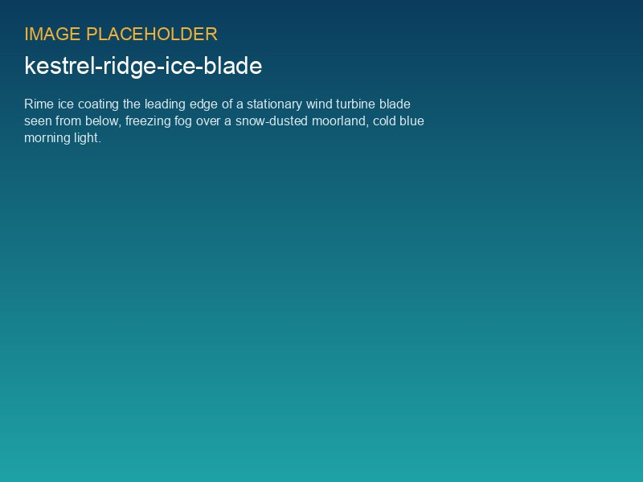
Rime ice on a Kestrel Ridge blade, January 2025

5. Responsibilities
Role | Responsibility
Site Manager (Ben Okoye) | Owner of this procedure, beacon maintenance, decision on manual restarts
Control room | Monitor ice alarms, inform site manager, keep log
Highline Wind Services | Function test before winter, inspections on request
HSE Manager | Annual review, incident follow-up

6. Records
Ice stops and restarts are recorded in the SCADA event log and summarised in the monthly report. In winter 2024/25 we recorded 27 turbine-days of ice stops; 21 restarts were automatic and 6 manual. No ice fragments were found outside the 117 m ice fall zone during post-event checks.

